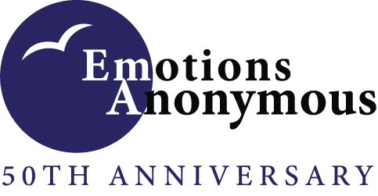

Reflections on Step 2

Step 2: Came to believe that a Power greater than ourselves could restore us to sanity.

“The principle embodied in Step 2 is hope. After admitting my powerlessness in Step 1, I had to muster up some kind of hope that I would get or gain some power from somewhere that would help me; and I knew it wouldn't come from me or I knew I didn't have it in me because I battled this thing of powerlessness over my Emotions for as long as I could remember but it just got progressively worse or I became increasingly powerless until I had nowhere else to turn. Everyone does not come from this place, but I was going to either kill myself when I left my first meeting or actually try the program because those were my absolute last 2 options. So, you know what happened. I am here to tell the story. I thank God for Emotions Anonymous and I thank Emotions Anonymous for getting me back in touch with that Power that has restored me to sanity and continues to allow me, I like to say, to pass as a sane person. I still have some deep issues that I am working on and will be working on until they throw dirt on me. When I work through one issue, another one presents itself. And new issues are added every day. Like right now as I write, for example, I am working on my acceptance of the coronavirus/covid 19 pandemic. Accepting that it is what it is, that it is still killing people every day and I have to do what I have to do to protect myself and others. This is just one, but there are others that I am working on simultaneously. I honestly do not know where I would be without Emotions Anonymous and all the support it provides me. I really don't even want to think about it.” — Derita P., *EAI Trustee*

“The concept “I cannot make myself well” that I learned in Step 1 allowed me to accept the hope of another way to get well found in Step 2. When I first read this step, I felt someone like me did not deserve sanity. It seemed impossible that I would ever be restored to sanity if I didn’t even know what that meant. The EA Big Book simply defines sanity and insanity. Knowing that I need to incorporate Step 2 into my life must mean I am insane. My old beliefs caused me to think some Higher Power would not help an insane person. In this program, I have learned this power greater than myself will always meet me exactly where I am. It was in EA that I learned that I can develop my own belief system. The way it is written in black and white in our Big Book allowed me to believe what I was being told. I was also excited to learn that this step works for us even before we completely develop our belief system. It is enough to begin with honesty, open-mindedness and willingness to believe. Through working the program, my self-esteem increased. As I began to believe in myself more, I came to believe I deserve sanity. Once I began to see myself for who I am, I became more open-minded to a power greater than myself restoring me to sanity. To put this restoration to sanity into action, I began to do sane things. I was once told “start doing the small things well so you can do the big things well too.” Examples of “small” things that helped me are: make my bed every day, put away my laundry and regularly do self-care. I challenge you to look around and see in what ways your higher power is helping restore you to sanity.” — Kelsey W., *EAI Board Member*

“Before I came to this program, I thought I believed in a Higher Power.

But when I did my second step, I realized that I had confused my position and my Higher Power. I wanted to decide what would happen and what would not happen for my life instead of him.

And if something went wrong with me, I would get involved with him and eventually get disappointed with him.

I was not willing to receive help to heal my emotions from a Higher Power, and I could not heal myself as well. With the second step, I realized that higher power helps me, I just have to reach out to him.” — Behzad D., *EAI Board Member*

“If I didn't believe that HP could restore my sanity and help me to live a life of my choosing, I would have no reason for hope. I find hope to be so important in life. Hope for a good day, hope that I can overcome obstacles and hope that things can be better. When I have seen my darkest moments has been when I lost hope and it was at those same times that I lost  faith that God was paying attention to me. Being in the program and working the steps helps me to stay away from those darkest moments. It helps me to remember that God wants me to have a peaceful life and that I need to show trust and faith in order for that to happen and in order for me to be able to work the program to its full potential.” — Paul N., *EAI Treasurer*