EA through the Holidays Worldwide 2021
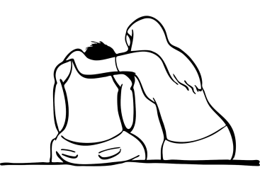
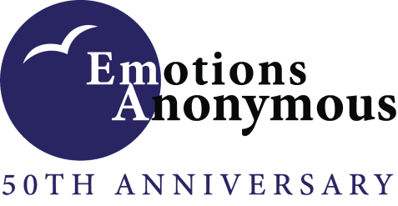

These spring sessions are for you if you…
Are struggling with forgiveness, guilt or grief
Desire to be free of guilt and shame
Want to enter the acceptance stage of grief
Want to experience gratitude and happiness

Saturday, April 3 & Sunday, April 4, 2021
Morning: | 11 AM, EST | 10 AM, CST | 9 AM, MST | 8 AM, PST
Afternoon: | 3 PM, EST | 2 PM, CST | 1 PM, MST | 12 PM (noon), PST
Evening: | 8 PM, EST | 7 PM, CST | 6 PM, MST | 5 PM, PST

Jumpstart the Holiday with emotions pamphlets in the morning
(Guilt (#94), Grief (#55) and/or Forgiveness (#51))
Continue the day with a story of recovery in the afternoon
Wind down in the evening with recovery topics and gratitude
JOIN US…by Phone -
Within the USA: (712) 451-1140, Participant Access Code: 808747#
Across the globe: https://fccdl.in/i/eatelephoneconference5
JOIN US…ONLINE -
1. Go to www.FreeConferenceCall.com and click on LOG IN
2. Click on JOIN MEETING along the top
3. Enter the meeting ID: eatelephoneconference5 (exactly as written)
4. Type in your Name and Email; then click on JOIN
5. Click on the HANDSET icon
6. Click on the MIC & SPEAKERS or TELEPHONE HANDSET icon
We use the Yellow Pamphlet during the meetings.
#1 — EA's 12 Step Program (The Yellow Pamphlet)
No registration or fees required. Volunteers are needed to be moderators and speakers. Please contact us if you want to volunteer or have any questions: eastepstudy12@gmail.com
Find out what Emotions Anonymous has to offer you at
www.emotionsanonymous.org or call 651-647-9712

