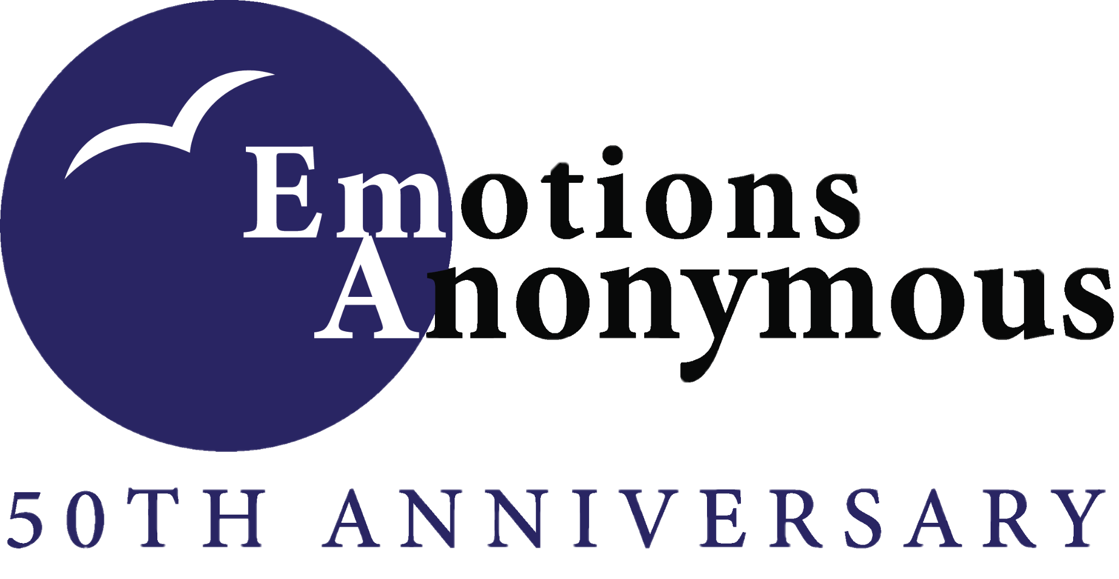
New Group Scholarship Application 2022

Application Date:
Main Contact’s First & Last Name:
Main Contact’s Phone & Email:

Group’s Main Contact’s Mailing Address:

What type of EA meeting will you be starting?
- Face-to-Face
- Hybrid
- Remote or Virtual
Meeting Start Date:
Type of Building (library, community center, etc.):
Meeting Location Name (if applicable):

Meeting Location Address:

Meeting Platform (Zoom, Skype, etc.):
How members can access the meeting (face-to-face, phone, online, app):

Time and day of planned meeting:
Verification of Insurance:
___ location requires insurance and insurance will be paid by: ___________________
___ location does not require insurance.
*Submission of this information does not guarantee approval. If the New Group Scholarship Fund does not have funds available, those requesting assistance may be placed on a waiting list until funds are available. No scholarships will be made in advance of funds being available.

