LEWIS AND CLARK RECOVERY CAMPOUT
14TH ANNIVERSARY
Sharing Our Experience, Strength and Hope “If your are not satisfied with your recovery, we will gladly refund your misery.”
September 20th – 22th, 2019
Lewis and Clark State Park, Onawa, Iowa
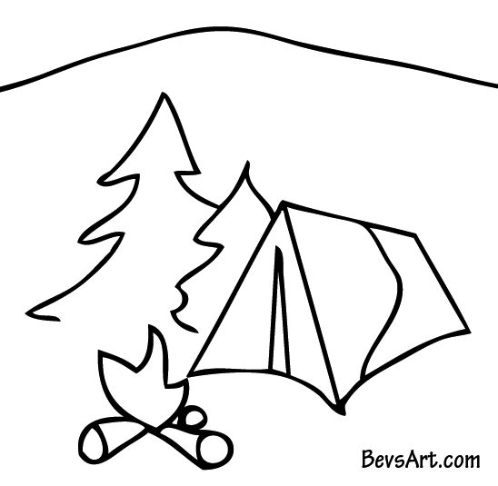
Make reservations for camping ahead of time, spaces fill-up fast: Reserving Camp Spots Online:
https://www.iowadnr.gov/Places-to-Go/State-Parks/Iowa-State-Parks/ParkDetails/ParkID/610142

Note: State Policy! Those persons not camping on Friday and Saturday, are required to leave the park before 10:00 pm. Thank you for your understanding, patience and cooperation! “Love and tolerance of others is our code.” AA Big Book p. 84

Super 8 Hotel is also available if you would just like to participate in the activities, meetings and fellowship. Call: (712) 423-2101 for reservations.

Friday Night: 8:00pm Open Alcoholics Anonymous Campfire Meeting

Saturday Morning: 7:00am Breakfast at the Lodge
8:00am Open Alcoholics Anonymous Meeting at the Lodge
10:00am Narcotics Anonymous Speaker Meeting: George O., Logan, Ia
Saturday Afternoon: 12:00pm Lunch at the Lodge
2:00pm Open Alanon Meeting - Lodge
4:00pm Emotions Anonymous Speaker: TBA
5:00pm Potluck at the Lodge
6:00pm Alanon Speaker: Jack O. – Omaha, Ne.
7:00pm Alcoholics Anonymous Speaker: Dennis B. - Holstein, IA

8:30pm Open Alcoholics Anonymous Campfire Meeting

Sunday: 10:00am Spiritual Speaker: Patrick C.: Wisner, NE

Come join us for Camping – Games - Fishing – Boating - Fellowship - Fun
(Maybe even do some meetings along the way.)

Any Questions, call: 712-420-3013, or 712-420-2058

DIRECTIONS ON OTHER SIDE >>

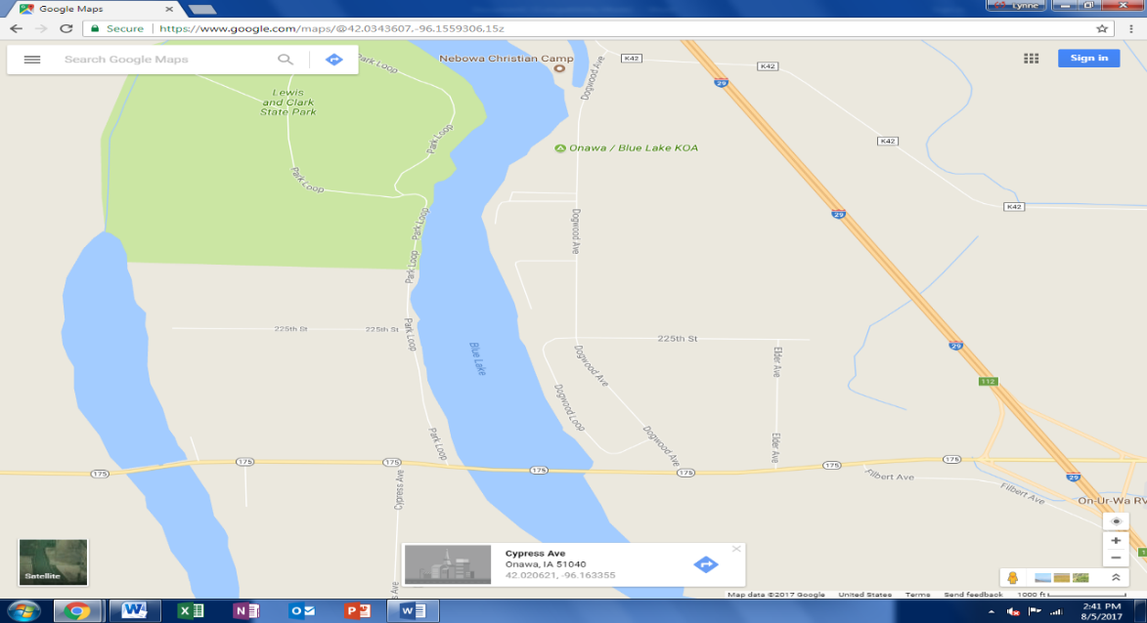

From Interstate 29 (I-29) take exit 112 to Hwy 175

On Hwy 175 head west of Onawa, Iowa until you come to Park Loop –
Turn North on Park Loop (You are now at the Lewis and Clark State Park)
Continue heading north until you come to the Cabin Reception Center (Lodge) on the right.
You have arrived as pictured below: Further down the road are the camping areas.
