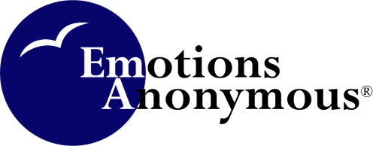

Agenda
Book & Literature Committee
May 10, 2016
6:00 p.m. (in Minnesota)
Conference Call # 1-866-316-1519
Participant code: 67734578#
Moderator code: 63622386 (only 1st caller needs)

Committee members:
Lynne S.
Ron R.
Frances V.
Larry B.
Lisa G.
- Open with the Serenity prayer

- Review Previous Meeting’s Minutes (March)

- Old Business:
  - Book and Lit. Committee Final version for Policies and Procedures
  - Finalize Book & Literature Committee Qualifications and B & L Approval Criteria
  - 4th Step Workbook review
  - World View Daily Reading Book - Next steps

- New Business:
  - How to tell the EA membership that we are open to new materials?
  - Development process for new pamphlets
  - Any other New Business

- Next Meeting date

- Serenity Prayer

