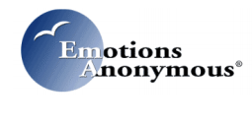
SAVE THE DATE!
EA Telephone Conference 2018
Experience, Strength & Hope
Saturday, October 27, 2018
9:30 am to 5:00 pm EST
Join in Across the globe!
JOIN BY PHONE
To join us in the USA; call (712) 451-1140 Access Code: 808747
Check this link to see if your country has a local phone number to dial in https://fccdl.in/i/eatelephoneconference5
JOIN THE CONFERENCE ONLINE
1. From GOOGLE CHROME or MOZILLA FIREFOX: Go to www.FreeConferenceCall.com
2. Click on LOG IN, then MENU and on the drop down select JOIN MEETING
3. Enter the meeting ID: eatelephoneconference5 (Case sensitive)
4. Type in your Name and Email and then click on JOIN
5. Click on the MIC & SPEAKERS icon then click on CONNECT NOW
6. Click on the telephone handset icon and Use the keypad to click on *6 to mute and unmute OR click on the microphone icon to mute and unmute
Check for updates on our event calendar @
https://emotionsanonymous-org.presencehost.net/what-we-offer/event-calendar.html

